***MEASURING SUCCESS IN TALENT MANAGEMENT***

***INTRODUCTION;***

***Talent management includes all the ways that organization bring employees on board keep them happy and productive, and help them continue to develop to their skills over time***

***EMPATHY MAP:***

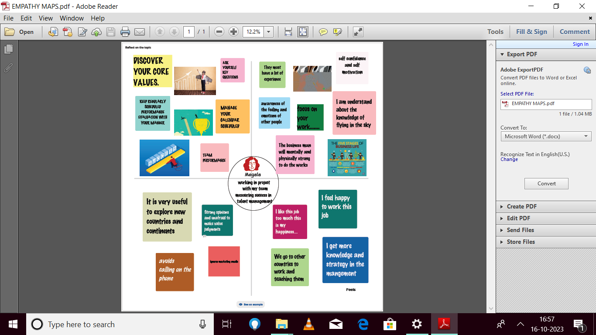

***BRAINSTORMING:***

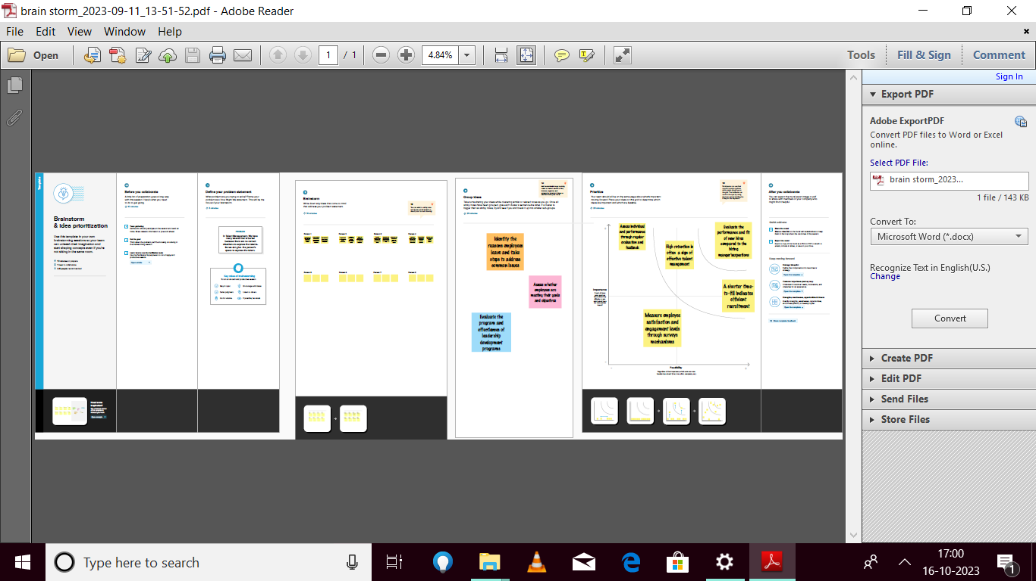

***RESULT:***

***1.We have taken a dataset and we analysis the data by using tableau***

***2.Tableau is the most powerful, secure, and flexible end-to-end analytics platform for your data. Elevate people with the power of data***

***3.Designed for the individuals, but scaled for the enterprise, tableau is the only business intelligence platform that turns your data into insights that drive action.***

***DASHBOARD***

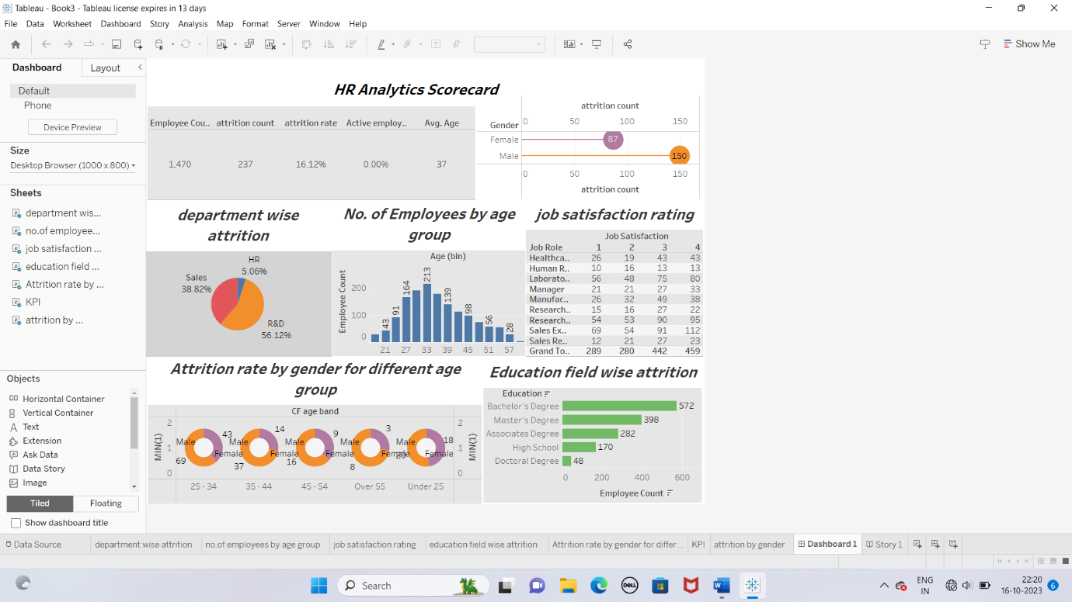

***STORY***

